EXERCISE 5: TASK MANAGEMENT SYSTEM USING LINKED LIST

Name: Shubham Sangram Bej
AIM
To implement a Task Management System using a Singly Linked List and perform add, search, traverse, and delete operations efficiently.
INTRODUCTION
Linked Lists are dynamic linear data structures used to store collections of data. Unlike arrays, linked lists do not require contiguous memory locations. Each element is stored inside a node, which contains data and a reference to the next node.
TYPES OF LINKED LISTS
- Singly Linked List
A Singly Linked List consists of nodes where each node contains data and a pointer to the next node.
Characteristics:
• Unidirectional traversal
• Easy to implement
• Dynamic memory allocation
• Efficient insertion and deletion
- Doubly Linked List
A Doubly Linked List contains two pointers in every node.
• Next Pointer
• Previous Pointer
Characteristics:
• Bidirectional traversal
• Faster deletion operations
• Requires extra memory

COMPARISON OF LINKED LISTS
Singly Linked List
• One pointer per node
• Less memory usage
• Forward traversal only
Doubly Linked List
• Two pointers per node
• More memory usage
• Forward and backward traversal
TASK CLASS
The Task class contains:
• Task ID
• Task Name
• Task Status
Each task object represents an individual task in the system.
IMPLEMENTATION
The Task Management System uses a Singly Linked List to perform:
- Add Task
A new task is inserted at the end of the linked list.
- Search Task
A task is searched using the Task ID.
- Traverse Tasks
All tasks present in the linked list are displayed.
- Delete Task
A task is removed from the linked list using its Task ID.
TIME COMPLEXITY ANALYSIS
Add Operation :-
Time Complexity: O(n)
Reason: Traversal is required to reach the last node.
Search Operation :-
Time Complexity: O(n)
Reason: The entire linked list may need to be traversed.
Traverse Operation :-
Time Complexity: O(n)
Reason: Each node is visited once.
Delete Operation :-
Time Complexity: O(n)
Reason: Searching for the target node requires traversal.
SUMMARY TABLE
Operation Time Complexity
Add: O(n)
Search: O(n)
Traverse: O(n)
Delete: O(n)
ADVANTAGES OF LINKED LISTS OVER ARRAYS
- Dynamic Size
Linked Lists can grow or shrink dynamically.
- Efficient Insertions and Deletions
No shifting of elements is required.
- Better Memory Utilisation
Memory is allocated only when needed.
- No Reallocation Overhead
Nodes are added dynamically without resizing.
- Suitable for Dynamic Applications
Useful when data changes frequently.
DISADVANTAGES OF LINKED LISTS
- Extra Memory Requirement
Each node stores a reference pointer.
- Sequential Access
Random access is not possible.
- Lower Cache Performance
Nodes are stored at different memory locations.

OUTPUT
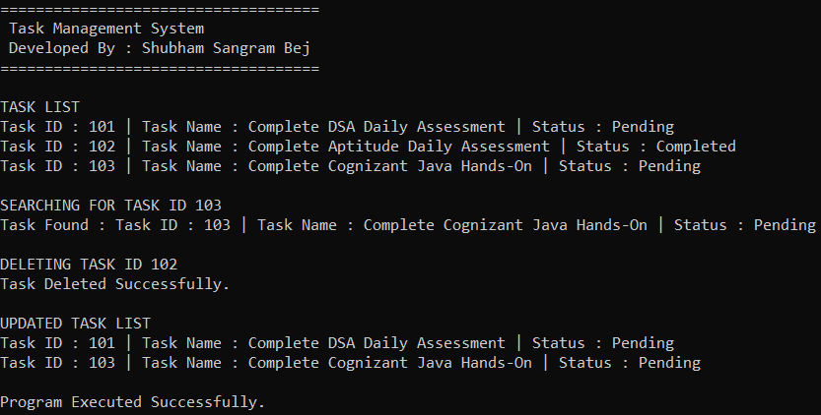
RESULT
The Task Management System was successfully implemented using a Singly Linked List. Tasks were added, searched, traversed, and deleted successfully.
CONCLUSION
This experiment demonstrated the implementation of a Singly Linked List for managing tasks dynamically. Linked Lists provide greater flexibility than arrays when dealing with frequently changing data and are widely used in real-world applications.

